TURKEY SHOOT RIFLE
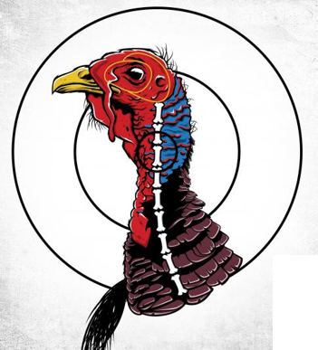
Full Name: _________________________________ Date: ____________
Phone: ______________ Email: ___________________________________
Circle: .22 Cal Rifle: Iron (Stand @ 10 Yards) Optic (Benched @ 25 Yards)
I sincerely shot this target at the required distance & dated listed above.
Signature: ________________________________________________
AVAILABLE ONLINE ONLY

